**CareNxt Wireframing**

|  |  |  |
| --- | --- | --- |
| **Wireframe Screen** | **Mapped FR** | **Purpose** |
| **1. Patient Login & Registration** | FR-001 | Entry point with OTP & profile setup |
| **2. Doctor Dashboard (Schedule)** | FR-002 | Set availability, clinic timings |
| **3. Appointment Booking Page** | FR-003 | Patient slot selection with filters |
| **4. Consultation Interface (Video)** | FR-004 | Doctor–patient consultation screen |
| **5. E-Prescription Form** | FR-005 | Create and preview prescriptions |
| **6. Medical History View** | FR-006 | Patient’s past consultations and Rx |
| **7. Notification Centre** | FR-007 | List of alerts, SMS/email preferences |
| **8. Admin Dashboard** | FR-008 | Control panel for doctors, reports, audits |

**FR-001: Patient Registration & Profile Management**

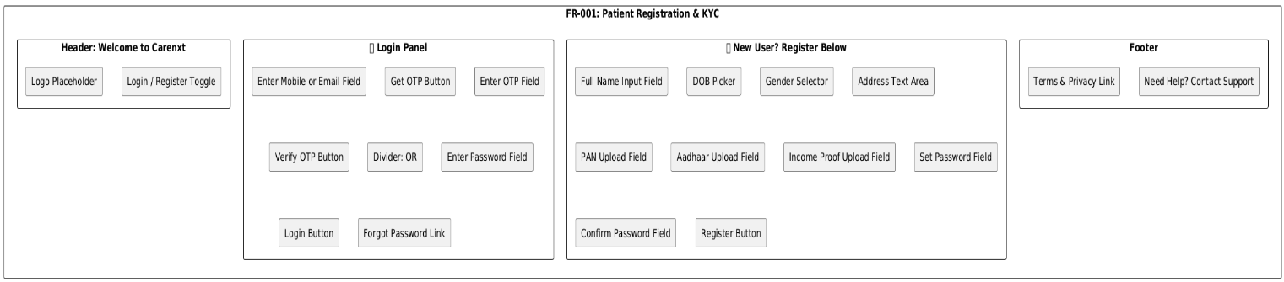

**FR-002: Doctor Schedule Setup**

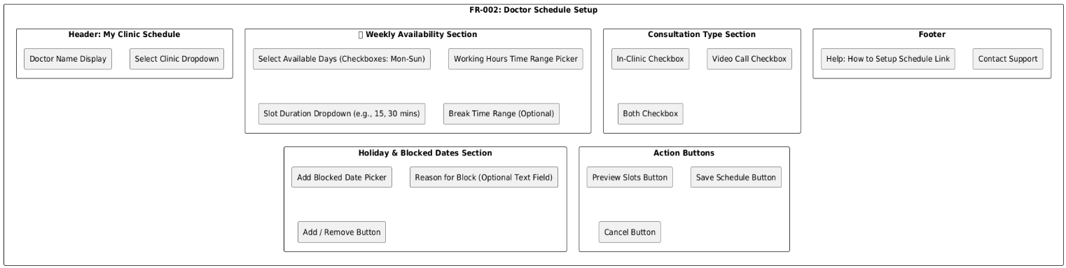

**FR-003: Appointment Booking Screen**

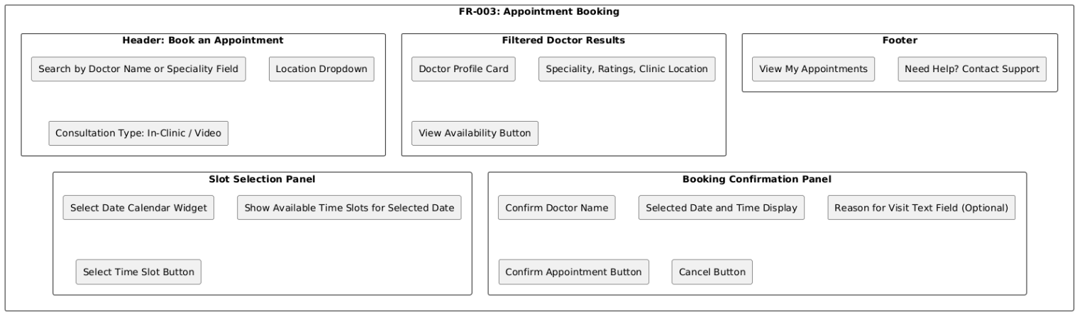

**FR-004: Consultation Interface (In-Clinic / Video)**

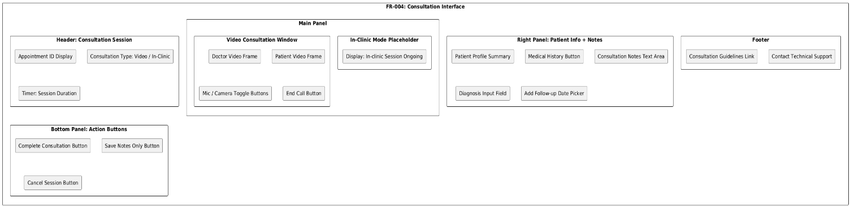

**FR-005: E-Prescription Generation**

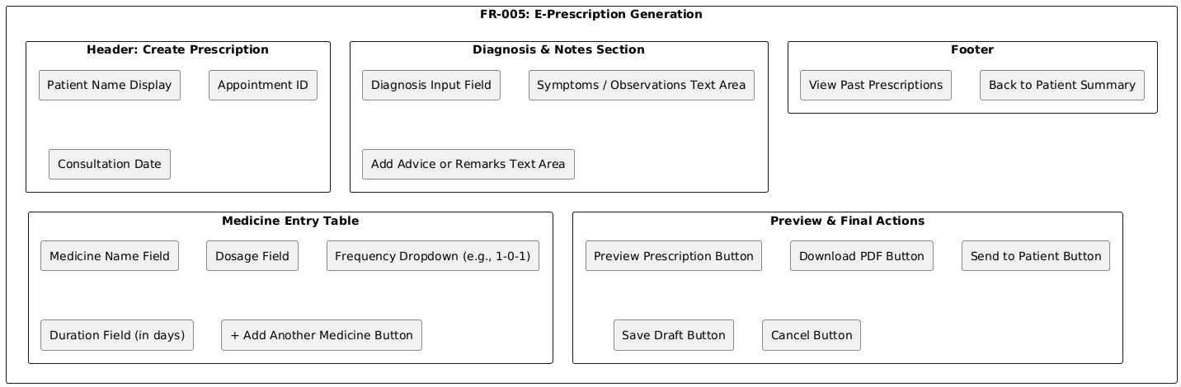

**FR-005: E-Prescription Generation**

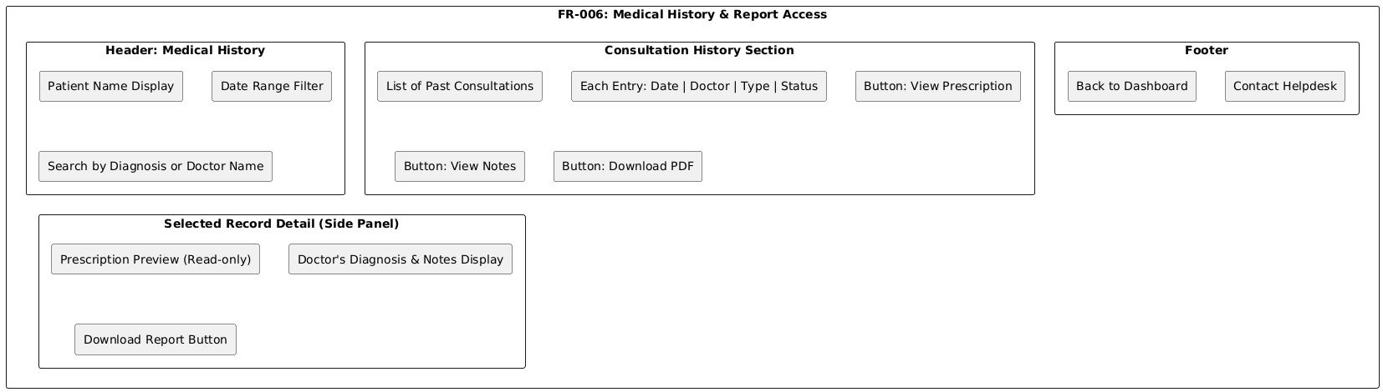

**FR-007: Notification & Reminder System**

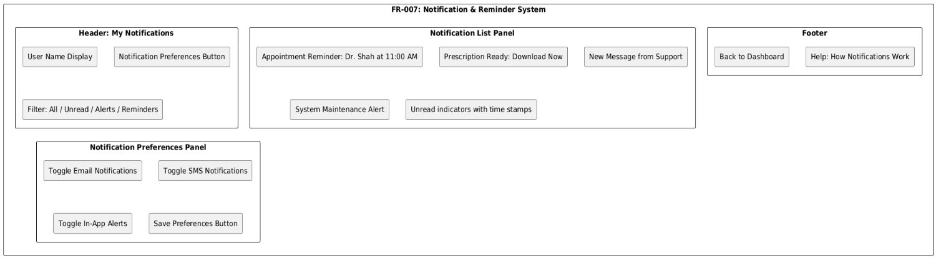

**FR-008: Admin Dashboard for Clinical Oversight**

